Larkin Wisdom

**Problem Statement**

I did the standard project as well as constructing a 2D B-Spline for extra credit. I created a Bezier patch with 16 control points. The four internal control points can be adjusted by their x, y, and z coordinates. A light source positioned at infinity points down over the surface, and can be adjusted by its x, y, and z coordinates using the menu. The camera can zoom in and out as well, relative to the z-coordinate. The surface is composed of triangles, but can be made solid. The light can be toggled between flat and smooth shading. The back-face of the surface cannot be seen, as it is removed with an algorithm. The diffuse and specular attributes of the light can also be adjusted. Finally, the scene can change to a 2D image with six points, that have a script “S” drawn. Each of the control points for this B-Spline curve can be moved around to adjust the curve.

**Algorithm Design**

The surface is constructed as a Bezier surface with the 16 control points. The surface is the sum of these control points, weighted with a Bezier control function. Adjusting the control points as a result adjusts the weight of the entire surface. Each line on the surface is drawn parametrically, from 0 to 1 on the x and z coordinates. The light options were all done using OpenGL functions. The B-Spline curve was constructed by creating functions that mimicked the construction of a B-Spline in the theory. The B-Spline function was a recursive function with a basis and recursive definitions, and the spline itself was the summation along all of the control points, weighted using the B-Spline function. The function used a knot vector which ranged parametric values from 0 to 1. These parametric values are how points on the polynomial were able to be formed, as the polynomial spline was of the form P(t), where t was the parametric parameter, same as used in the knot values.

**How to Run the Code**

Click on the .exe to run. Right-click anywhere to go to the menu. The last option will change to the B-Spline display. You can click and drag the points in the B-Spline display to change the curve.

**Screenshots**

Initial Scene

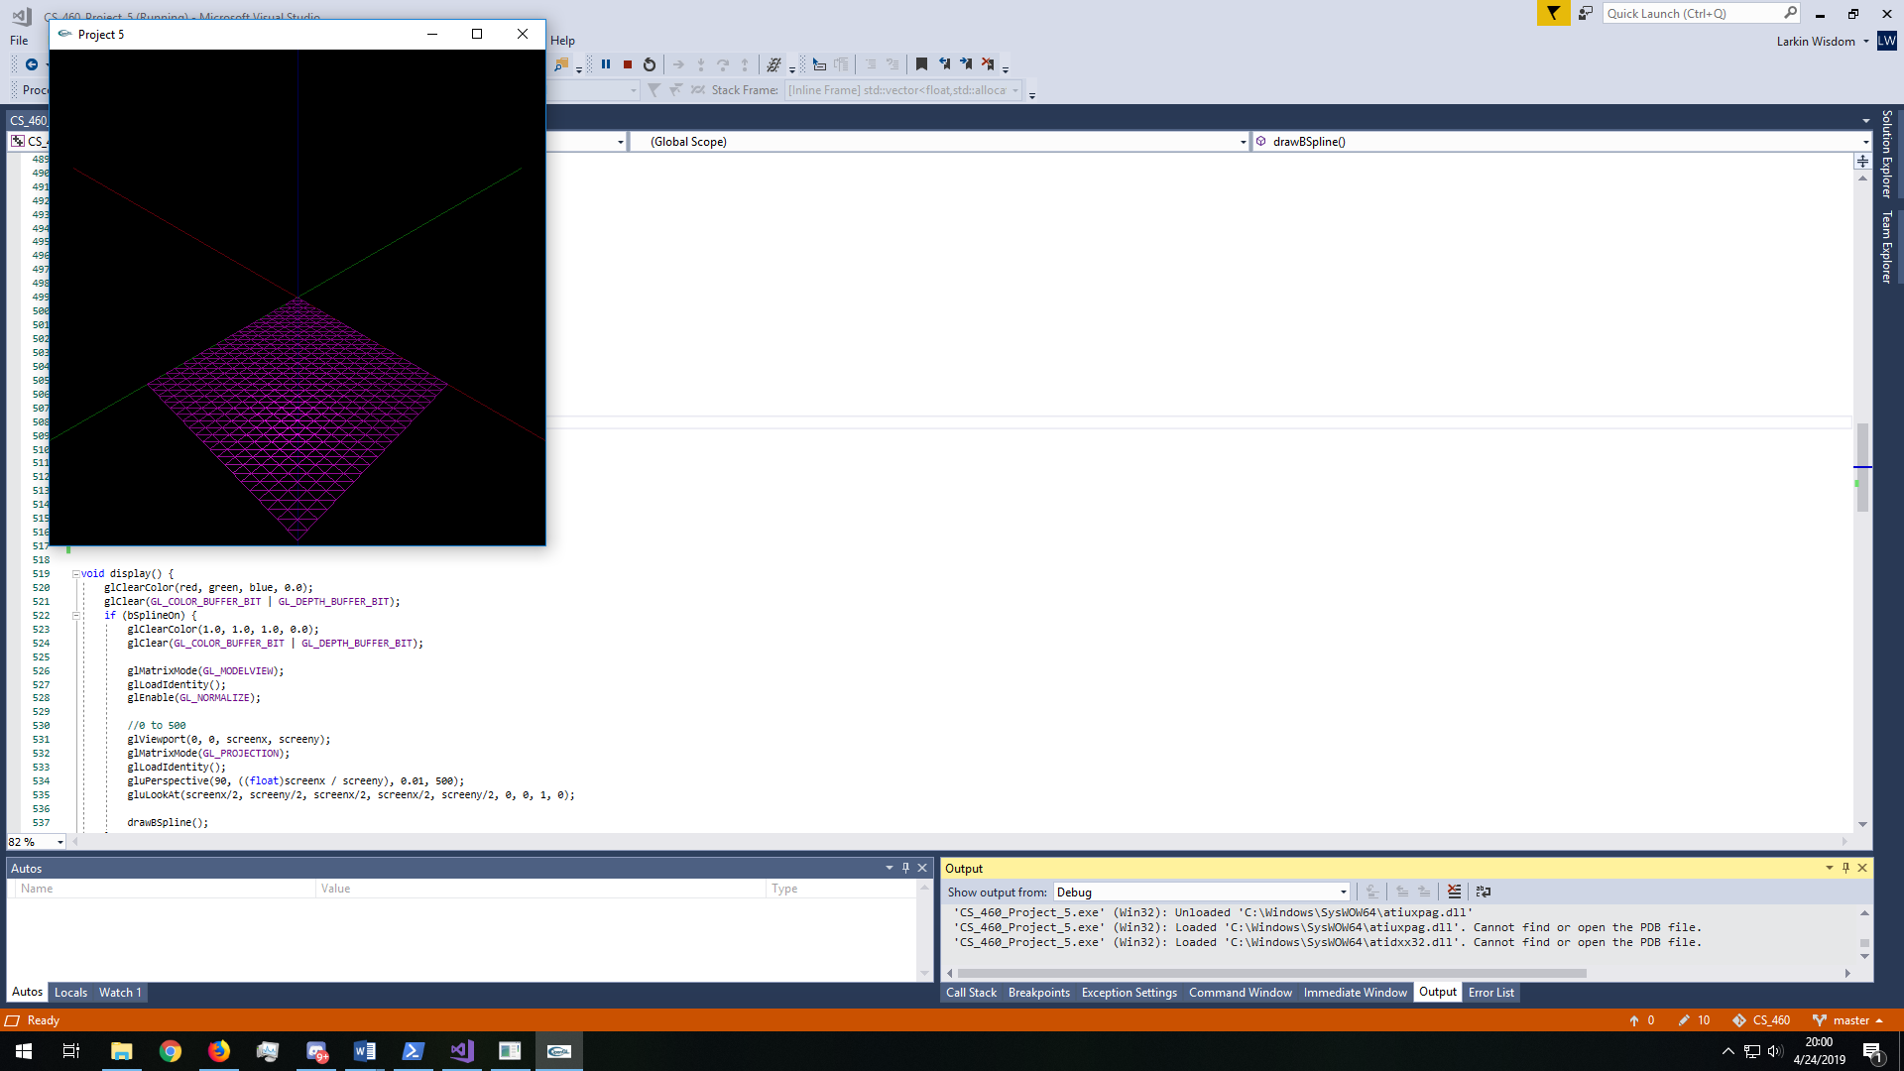

Enabling Surface

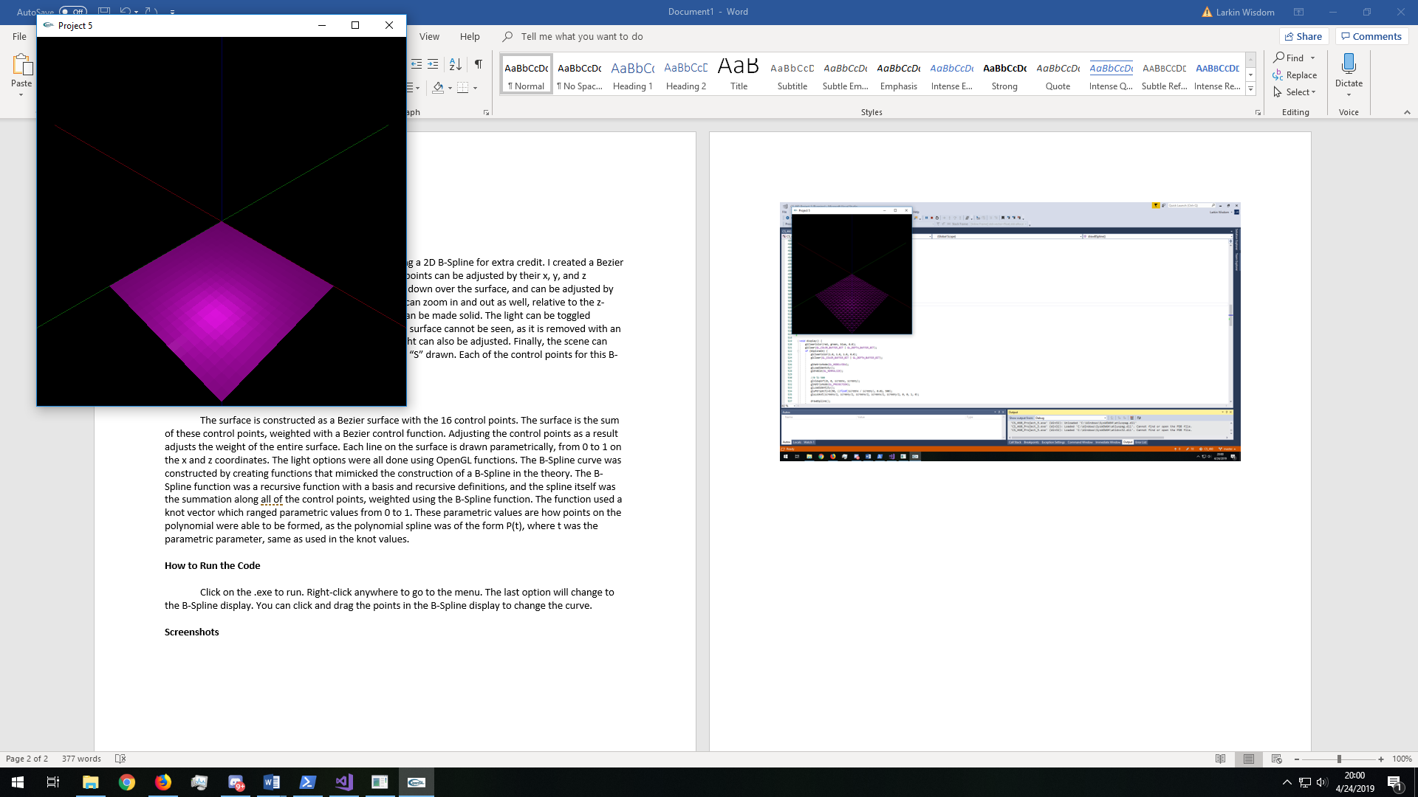

Changing to smooth lighting (default is flat)

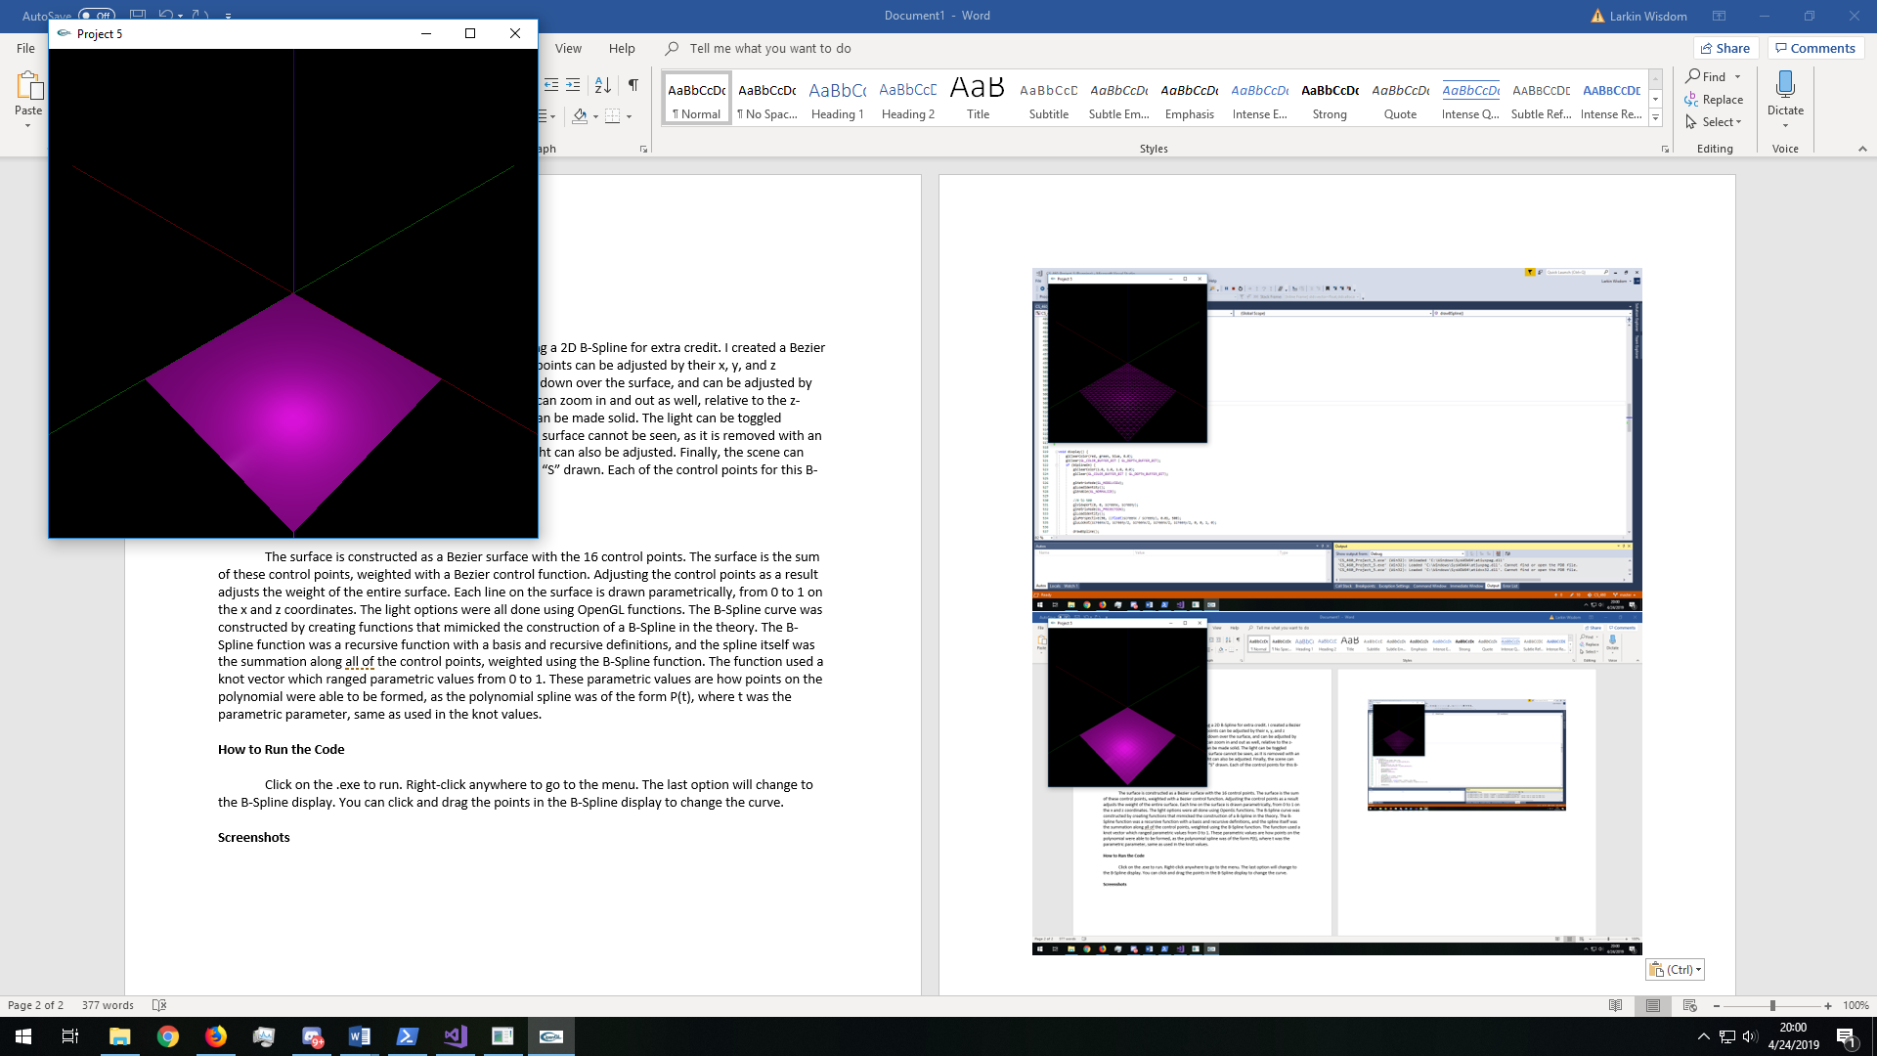

Adding a lot of diffuse

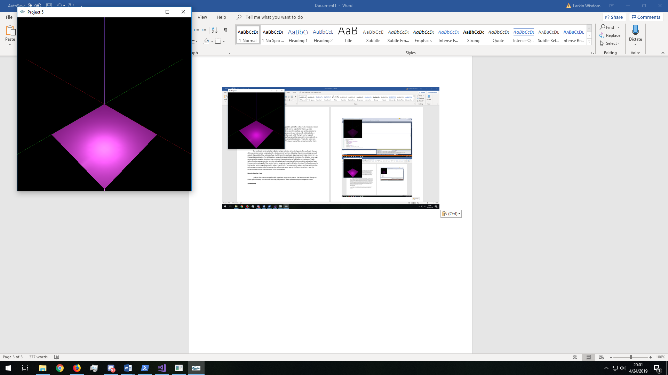

Adding a lot of specular

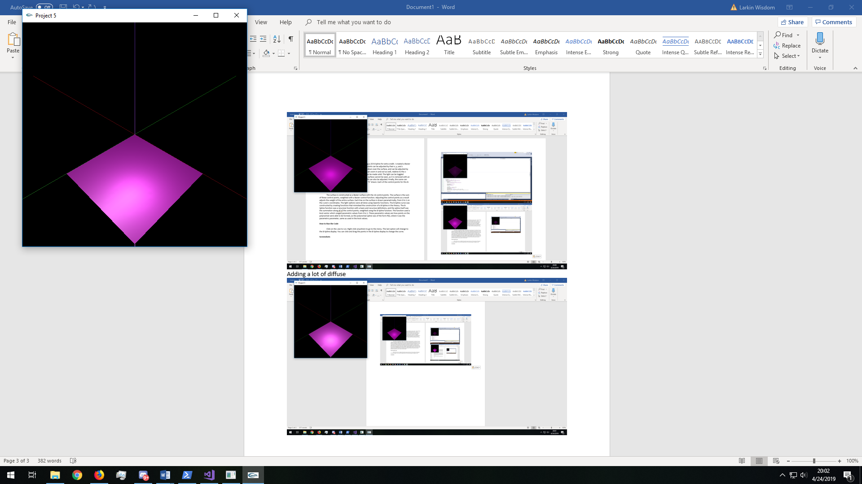

Moving the light source around the scene

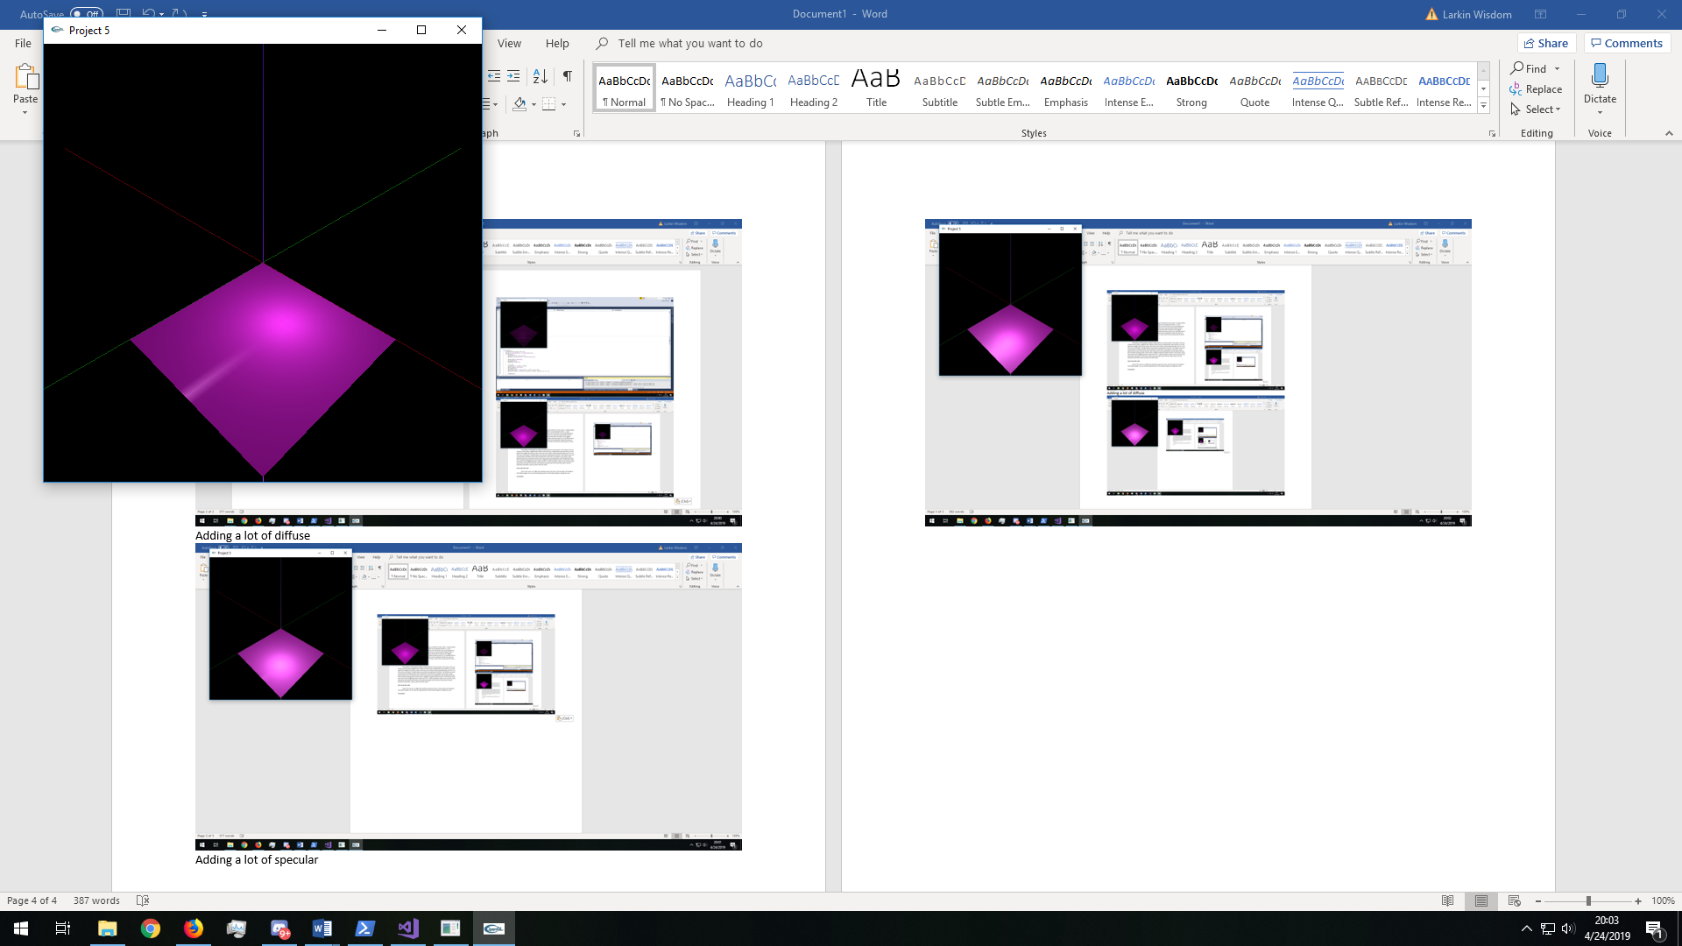

Bezier surface is deformed, and back-surface removal can be seen

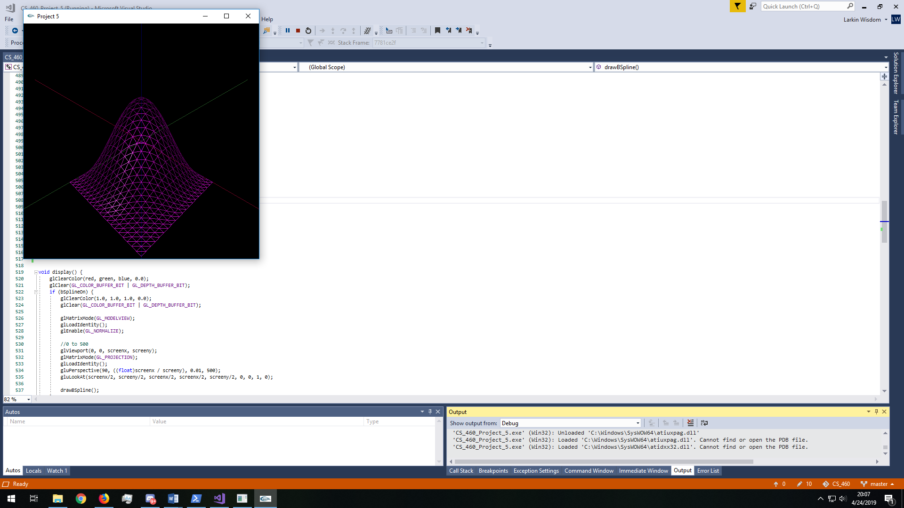

Zoom Function

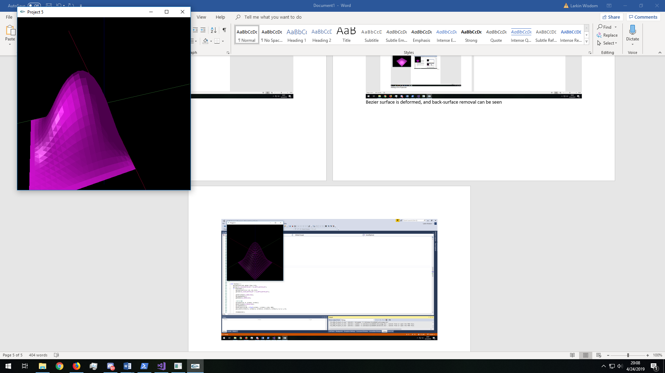

Default B-Spline with script “S”

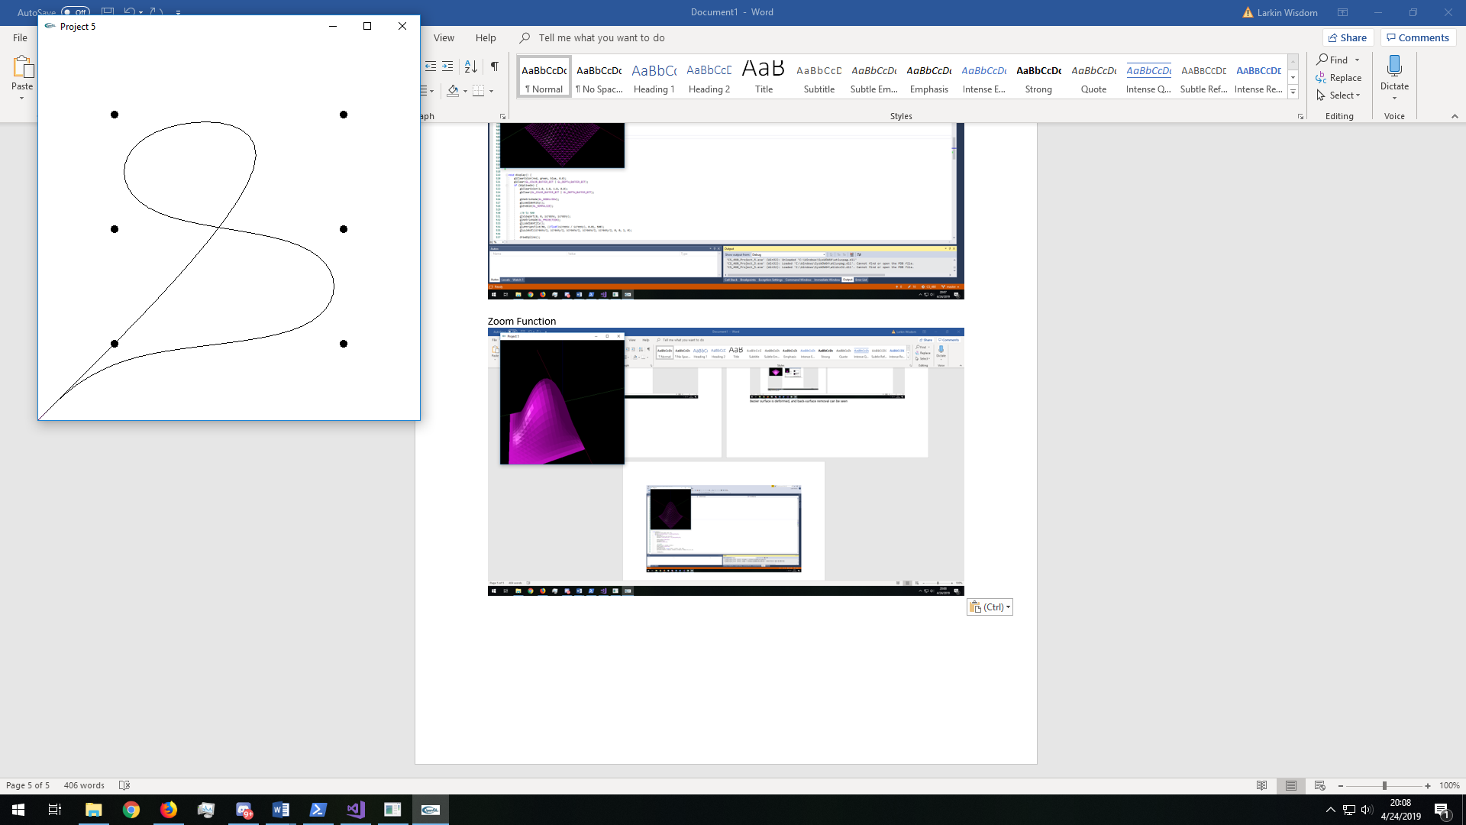

B-Spline after control points have been altered

